

Balkumari, Lalitpur

A

Minor Project

On

“**Product Recommendation System Using Collaborative Filtering**”

**Project Members**

Biru Nayak (KIC076BCT010)

Dev Narayan Tajpuriya (KIC076BCT013)

Dibya Ghimire (KIC076BCT015)

Prabidhi Shrestha (KIC076BCT022)

**DEPARTMENT OF COMPUTER AND ELECTRONICS &**

**COMMUNICATION ENGINEERING**

**LALITPUR, NEPAL**

**January 2023**

**Abstract**

The document is to present a bachelor’s project which seeks to display discount offer collection, provided by different online platforms. Nowadays, the customer has to visit different websites for the different types of discounts offered by the different platforms. Therefore, the motivation behind this website is to provide a platform for users to get the discount offers announced by different companies or platforms. Our website is focused on those people who prefer online shopping. Our website is also focused on those people who like discounts the most. Not only this but our website is also focused on those people who want to buy more products and also want to save money and time. Our aim is to arrange available discounts in the market, and e-commerce, provided by the companies, etc. in a systematic way on one website. And, for the development of our website, we use HTML, CSS, Python.

**Table of Contents**

Abstract………………………………………………………....…. 2

Table of Contents………………………………...………………... 3

List of Figures…………………………...……………………….... 4

List of Abbreviations…………………………...…………………. 4

1 Introduction…………………………...………………………… 5

1.1 Background.…………………………...……………….5

1.2 Problem Statement………………………….………….5

1.3 Objectives……………………………………………... 5

2 Literature Review…………………………...……………………6

3 Feasibility Study.…………………………...……………………7

3.1 Technical Feasibility …………………………...……...7

3.2 Financial Feasibility …………………………...………7

3.3 Schedule Feasibility …………………………...………7

3.4 Operational Feasibility …………………………...……7

4 Project Methodology…………………………...………………...8

4.1 Block Diagram………………………………………….8

4.2 Development Model…………………………...……....10

4.3 Use-case diagram………………………………………11

5 Implementation Plan …………………………...……………….11

5.1 Schedule …………………………...………………….11

5.2 Software Requirements…………………………...…...12

6 Expected Outcomes …………………………...………………...12

References…………………………...……………………………..13

**List Of Figures**

Figure 4.1 Block Diagram..........................................................................8

Figure 4.2 Modified Water Fall Model ………….....………...………...10

Figure 5.1 ER diagram of Product recommendation system……………….

Figure 5.2 Class diagram for Product Recommendation System…………….

Figure 5.3Use-case Diagram …………………………………………..11

Figure 5.4 Activity diagram of product recommendation system

**List of Abbreviations**

HTML Hypertext Markup Language

CSS Cascading Style Sheet

VS Code Visual Studio Code

**1. Introduction**

**1.1 Background**

As we know, discounts are very attractive to customers and may not only bring new clients but can also bring back previous customers. So, our website collects the various discounted products provided by the different platforms and provides them easily to the users and also recommends them. So, the users can easily get the various discounted products in one place. So it helps to save time and money for the users. The discount given in different categories like fashion items, electronic gadgets, etc. by the different online platforms is also included on our website.

Our website is beneficial for both customers and sellers (like online platforms). The customer can easily get the discounted products announced in the market. And the number of customers of the web applications can also increase. Therefore, our website helps to increase the sales of different ecommerce platforms.

**1.2 Problem Statement**

It is hardly possible to visit the different websites of different online business, e-commerce, etc. for getting a suitable price for the products which are available in the market. We cannot remember all the domains of the websites which are mentioned above or install all the applications where discount offers are available.

**1.3 Objectives**

To design a website to manage and recommend discounted products available in the market.

**2. Literature Review**

As technology has evolved, it has made the life of every individual easier. Nowadays, people have options and they try to choose the best one. So, we researched about the discount offers providing platform and some of the related projects.

Some of the related services available in Nepal like Daraz, eswa, foodmandu, khalti. All of these services were providing discounts in their individual platform. But as the technology is growing, people need more ease and features all at the same place. So our website is based on collecting all the discount available in the market.

Previous studies in marketing have shown that price discounts have both positive and negative effects on consumers’ buying behavior. It was identified that there are three routes of promotional effects: (a) economic, (b) informational and (c) affective. The final effect of a price promotion on purchasing decision is a combination of positive and negative economic, informational, affective influences[1].

According to Xia and Monroe (2009), their study resulted that consumers with a shopping goal are more responsive towards discount messages such as “pay less” and “discount” while consumers without shopping goal are responsive towards promotional messages such as “save more” and “free gift”. Xia and Monroe (2009, p.691) cited from (Monroe, 2003) that price promotion have several benefits such as to increase demand, adjust fluctuations in supply and demand, and increasing consumers’ purchasing over time [3].

The study of So, Wong and Sculli (2005) resulted that when there is the presence of discount offers, consumers will have higher intention to purchase in web-shopping; purchasing decisions and choice making from alternative evaluations can be made easily when there is the presence of discount offers[2].

**3. Feasibility Study**

**3.1 Technical Feasibility**

Our project is technically feasible as we use the latest programming language (python). Our website provides good service to both users and online platforms (who provides discount to the public). The system, which is being developed in the latest web technology available, can efficiently use the resources available and maximize output.

**3.2 Financial Feasibility**

Our project is economically feasible as it uses low cost for development. As our project is totally based on software development (i.e.no use of hardware component). So, minimum cost is required for development of our website. We use different programming language (like python, html, etc.) which are the free source language. Therefore, we have not to pay the money for it. Thus, our project is financially feasible.

**3.3 Schedule Feasibility**

* Analysis
* Feasibility analysis- about 10 days
* Requirements specification-about 15 days
* Design- about 25 days
* Coding– about 128 days
* Testing and implementation – about 30 days
* Documentation-about 208 days

**3.4 Operational Feasibility**

The project once completed shall be useful to the online platforms. The general difficulty level of the project has been kept low so as to ensure ease of operation. Our final project will be a web application and a user will need a computer/phone with an internet connection to utilize it

**4. Project Methodology**

**4.1 Block Diagram**

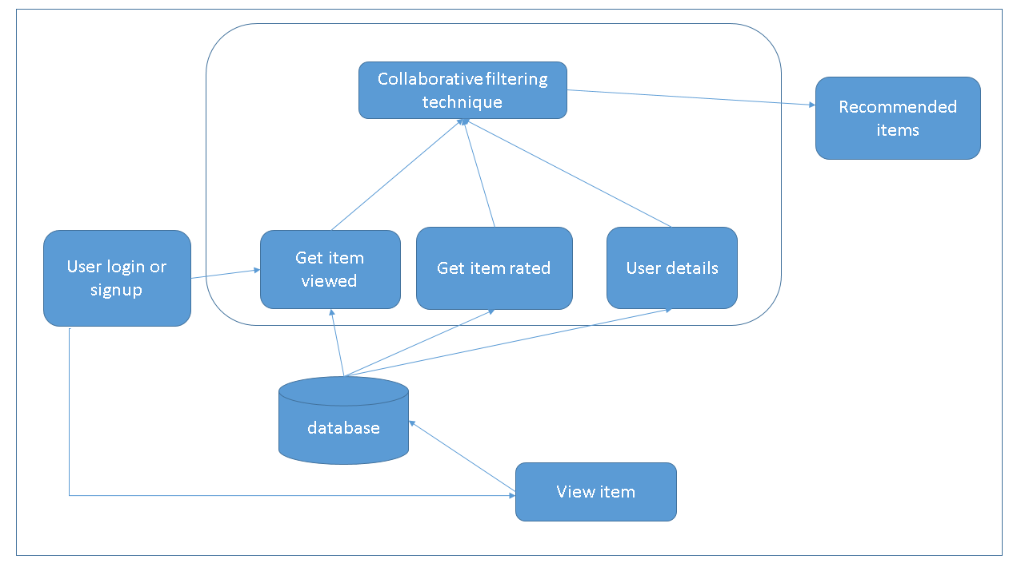

Fig 4.1 Block Diagram for product recommendation system

The above figure shows a block diagram for product recommendation system. When the user logs in or signs up in case of new user, s/he can view items and the search records are stored in database. From database user can get rated item, user details can be retrieved from database, viewed items can also be stored from database in user’s history. Recommendation process is done using collaborative filtering and then the users can get the items recommended.

**4.2 Development Model**

# **Our project follows the modified waterfall model**

* **THE MODIFIED WATERFALL MODEL**

The steps of the typical waterfall model are:

1. Requirement Gathering
2. Design
3. Implementation
4. Testing
5. Operation and maintenance

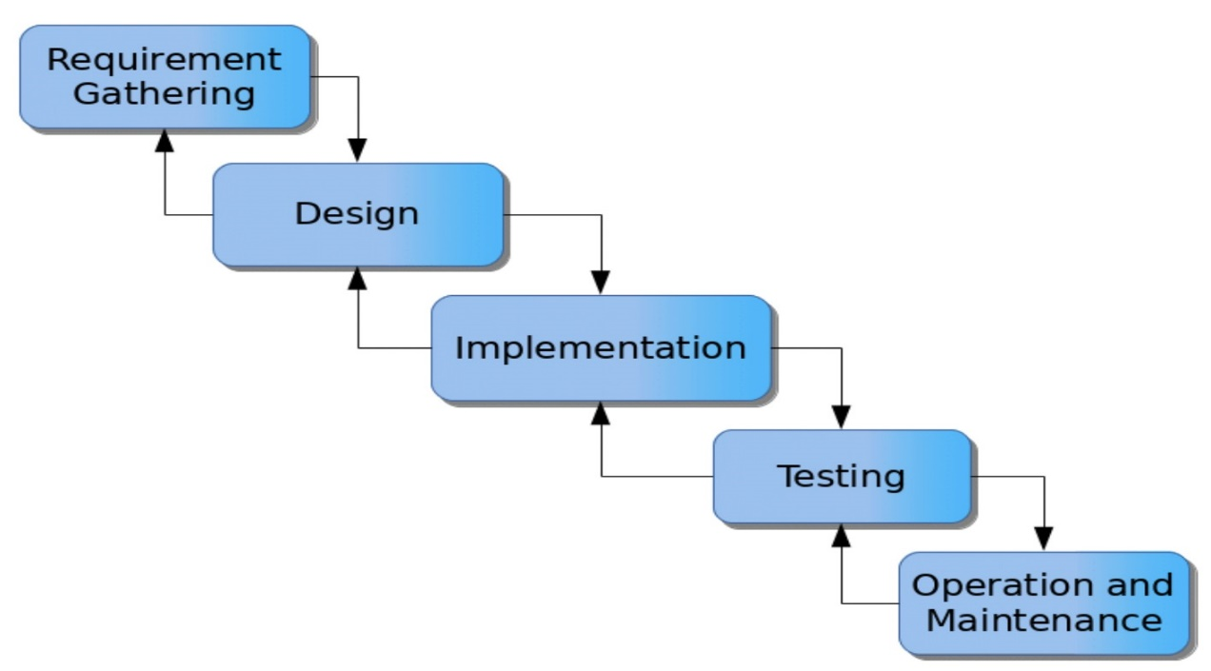

**[FIG 4.2: - MODIFIED WATERFALL MODEL [4]**

Waterfall model is a software development model, which was the first process model to be introduce by Dr. Winston W. Royce in a paper published in 1970. Above mentioned stages once completed cannot be jumped back to previous step in classical waterfall model.

So, to overcome this drawback, we are using modified water fall model to add a feedback system between stages. So that if any problem is found at one phase can cause remedial action to take at the previous step.

**5. Implementation**

**5.1 ER Diagram**

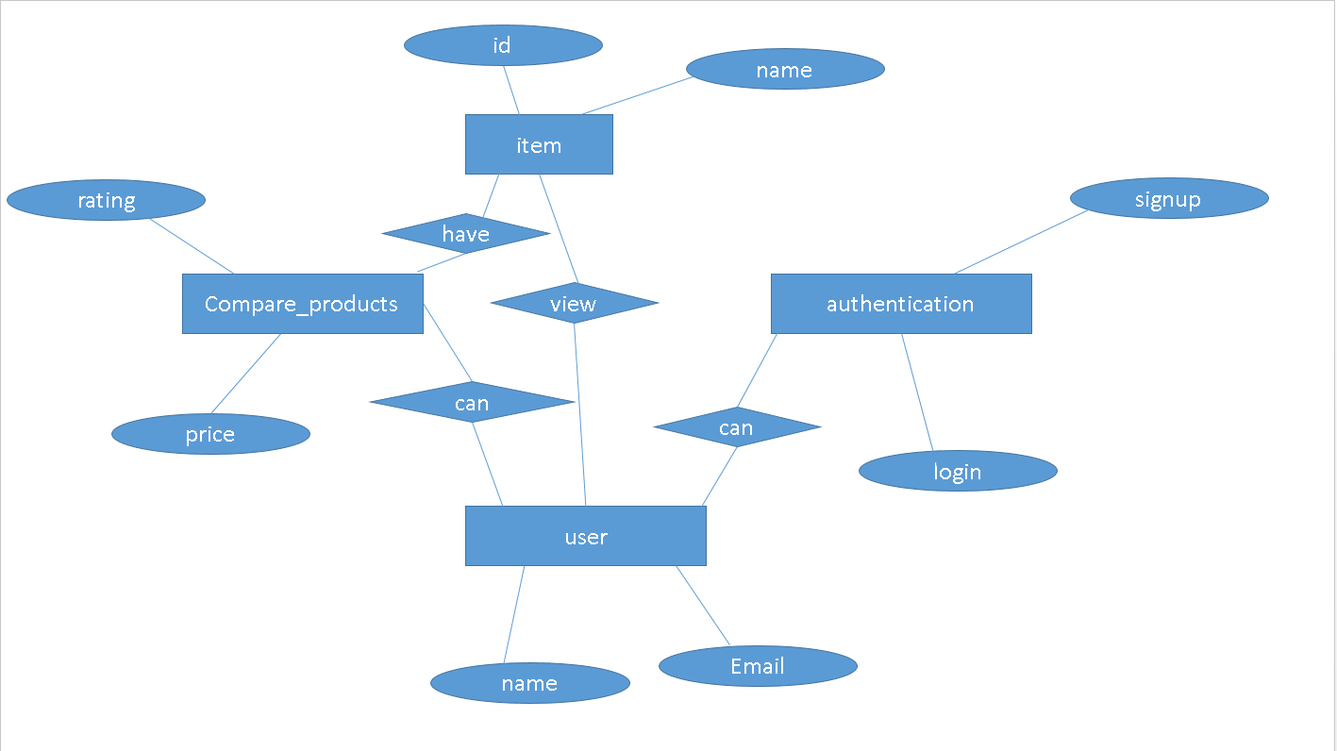

Figure 5.1 ER diagram of Product recommendation system

The above ER diagram shows the relationship between entire entities of the system. The entity user has attributes name and email. They can do authentication by signing up or logging in. The user can compare products according to price and ratings in them. Users can view items where items have names and id as their attributes. Comparison of products contains different items.

**5.2 Class Diagram**

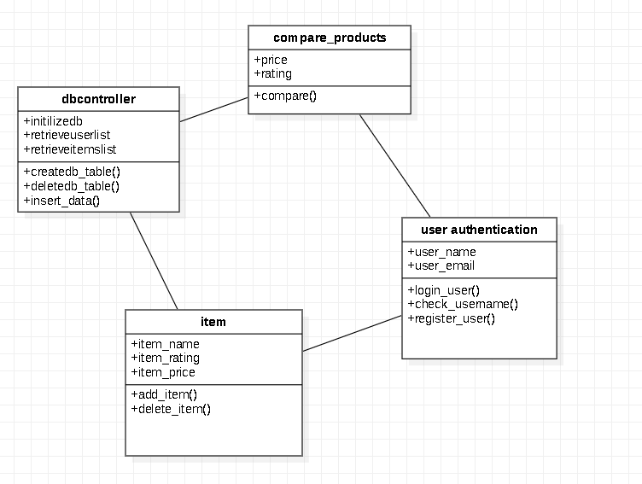

Figure 5.2 Class diagram for Product Recommendation System

User authentication class is utilized to get user information from the database and is for authenticating the users. The class diagram in above figure shows the methods that are used in this class and the description of each class. The function Check_User_Name checks to see if the provided username already exists in the database. If there is an existing user with the same name, then the user is prompted to select another username to create an account. Register User allows a new user to register for recommendation system account by entering a valid username and password. If the username already exists in database, the user will be prompted to choose another name. login_user allows the existing users to log in to the database with the credentials they used for first registering into the application.

dB controller class is used for getting users and product information from the database, and it is also used to update the database with the information about new-user registration and user details. The function createdb_table , deletedb_table, insert_table are used by admin to create, delete and insert database.

Compare_product class is used for comparing the products according to the user ratings and price of products.

The class items is used for adding or deleting the items by admin only.

**5.3 Use case diagram**

The system’s use case shows a detailed view of the system and how the actors would interact with each other and with the system.

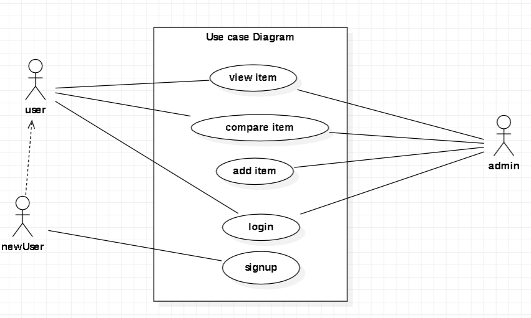

Fig 5.3 Use case diagram of product recommendation system

Fig 5.1 represents use case diagram for user and admin where they have access to login, view item, compare item, add item(admin), sign up(new user).

**5.4 Activity Diagram**

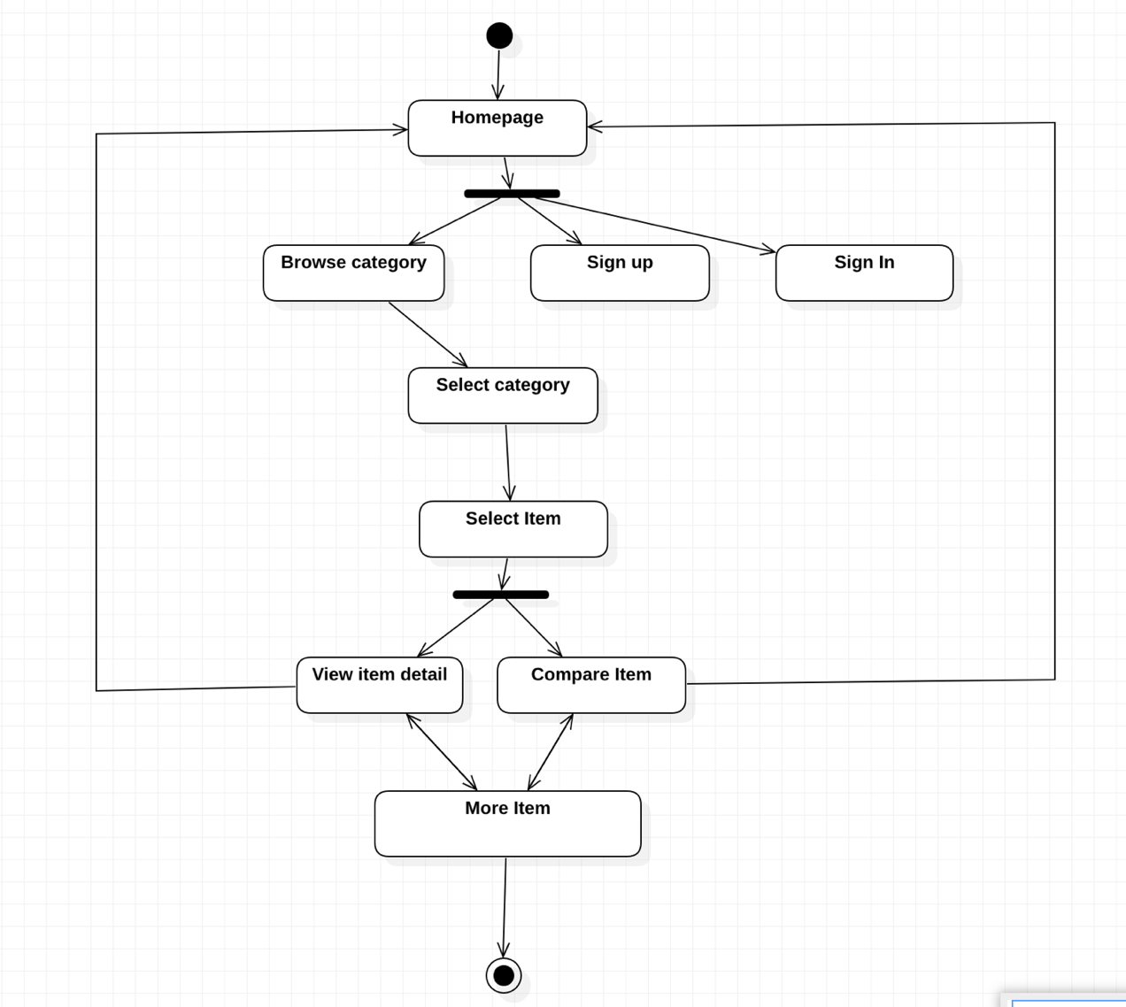

Figure 5.4 Activity diagram of product recommendation system

The figure above demonstrates the activity flow for this product recommendation system.The flow of the application is similar for both the user and administrator. The flow begins when the user first runs the application home screen in the web browser. The user can browse through the available list of categories and can select view more information for details about a particular item. The user can log in with username and password or sign up if s/he is a new user. They can select category and then select item included in it. The user can also compare the item. More items can be recommended to the user according to their history and the product ratings.

**5.2 Software Requirements**

* Python
* HTML
* CSS
* VS code

**References**